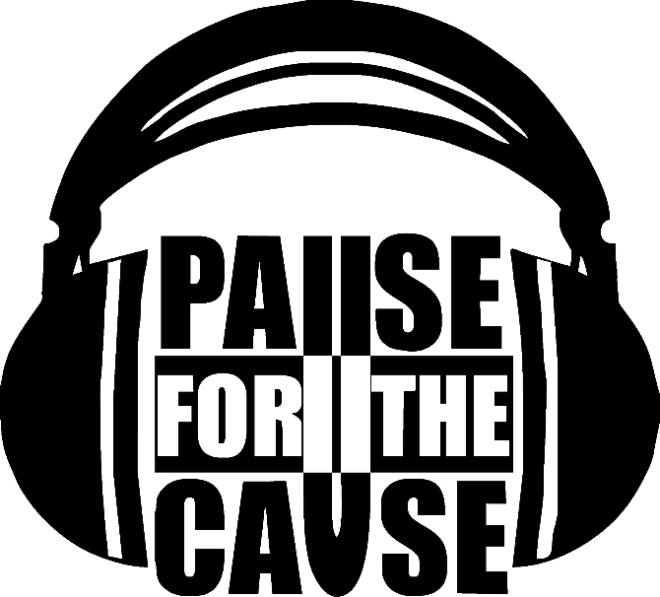

Pause For The Cause is a Boise Idaho based band consisting of three members; Steve Cash on guitar, Darcy Erickson on bass, and Michael Tetro on drums . All three sing to create a power trio of rock, hip hop, reggae and pop punk, performed with immaculate precision and delivered in an amazing and entertaining stage show. Since 2011, Pause For The Cause has emerged out of the mainstream to walk their own path creating their own style. Their unique sound is hard to categorize because they draw from so many genres but one thing is clear, their music is unforgettable and infectious. With two complete albums under their belt and a third on the way, Pause For The Cause delivers fresh upbeat originals which can be categorized with the likes of Sublime, Pepper, and Green Day. Their stage show consists of dynamic, high energy performance and crowd interaction.

Pause For The Cause continues to tour the U.S. and beyond, be on the lookout for new video content, tour footage and music videos added to their YouTube page soon!